1. Write a blog on Difference between HTTP1.1 vs HTTP2

* Ans:
* HTTP1.1 VS BETWEEN HTTP2:
* Hyper text transfer protocol
* Developed by Timothy Berners-Lee in 1989
* HTTP is a top-level application protocol that exchanges information between a client computer and a local or remote web server.

### [HTTP/1.1](https://www.digitalocean.com/community/tutorials/http-1-1-vs-http-2-what-s-the-difference#http-1-1)

* client sends a text-based request to a server by calling a method like GET or POST. In response, the server sends a resource like an HTML page back to the client.
* 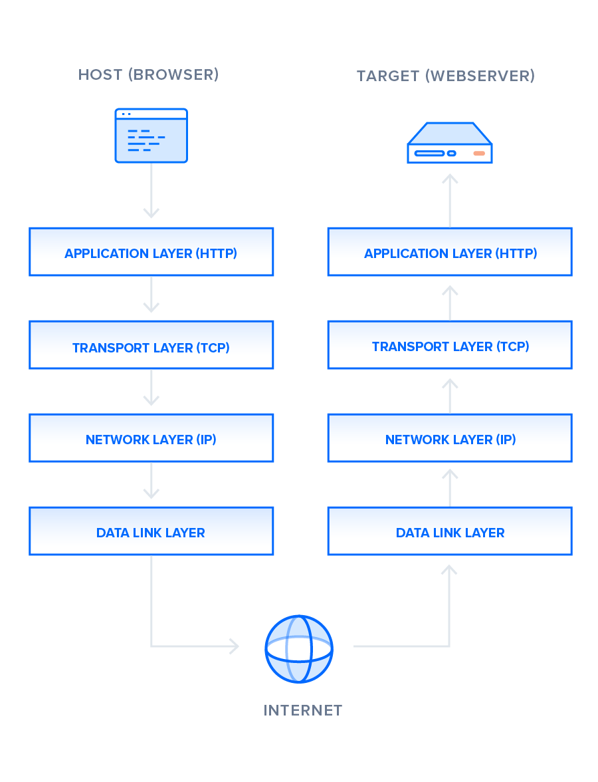

### [HTTP/2](https://www.digitalocean.com/community/tutorials/http-1-1-vs-http-2-what-s-the-difference#http-2)

### 

### [IETF (Internet Engineering Task Force)](https://www.ietf.org/)

### HTTP/2 began as the SPDY protocol, developed primarily at Google with the intention of reducing web page load latency by using techniques such as compression, multiplexing, and prioritization.

### browsers supported this standardization effort, including Chrome, Opera, Internet Explorer, and Safari.

2. write a blog about objects and its internal representation in javascript.

* Objects, in JavaScript, is it’s most important data-type and forms the building blocks for modern JavaScript.
* JavaScript’s primitive data-types(Number, String, Boolean, null, undefined and symbol) in the sense that while these primitive data-types all store a single value each (depending on their types).